# Steps for installing the System

* Clone the repo from provided link : <https://github.com/pranish33/Advance-Project.git>

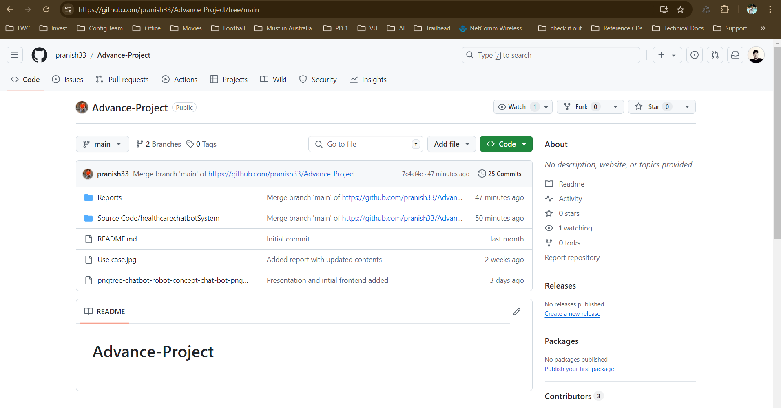

**Open the cloned project and open and please open the command line from bash and do the following commands as shown below:**

* Create environment using Python virtual environment
  + Command : python -m venv ‘environment_name’
* Install RASA Framework using Python 3.8.0
  + pip install rasa [‘full’]
* Install Django framework
  + Pip install Django
* Train The model
  + rasa train
* Run the server
  + rasa run
* Run the frontend server
  + python manage.py runserver

Then from the browser with server will be ready

URL: localhost:8000

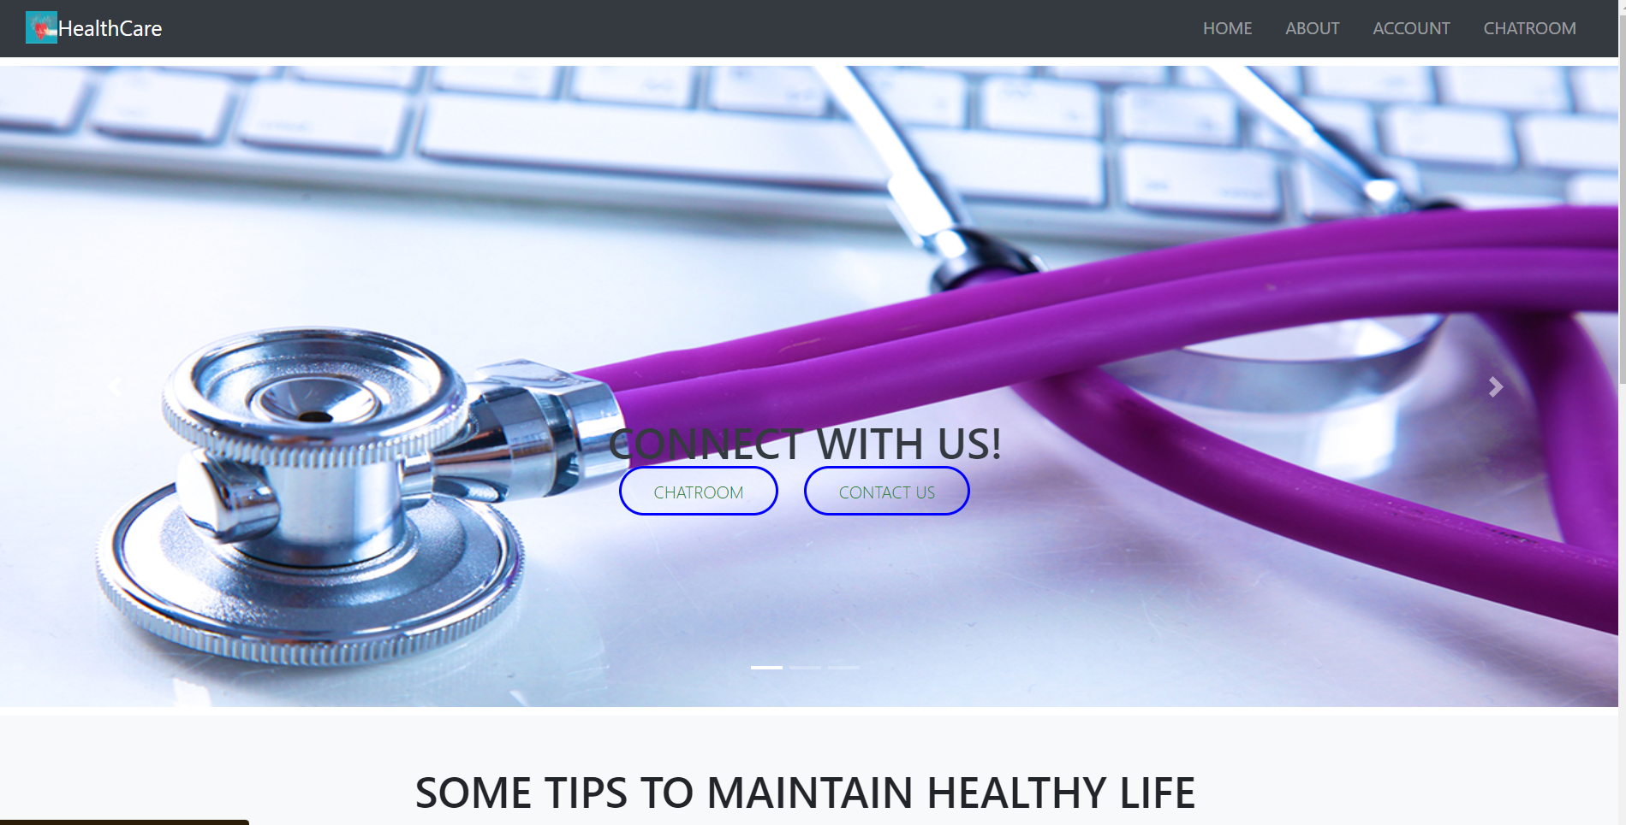

If you can’t see the provided screen you might have to check it from the command line.

**Some of the known issues**

* **KI1:** Database issues:
  + **Solution**: Need to migrate the model
* **KI2:** Version issues:
  + **Solution**: Need to downgrade the python if there is using higher versions
* **KI3:** Sever issues:
  + **Solution**: Server might not be listening from backend

***Please reach out to the team using above known issues code. In case the known issues are not found please raise a case with the screenshot of error from the command line.***